1, February 2017  
Simon Popecki  
Sydney Michalak  
SensitiviT Industries Ltd  
Nowhere, YS 66666

Mr. Cake,

As you have requested, we have reviewed the methods for determining the thermal time constant τ of your temperature sensors in water under varying conditions. In addition to your current method of determining the onset of the temperature change- the five-sigma method, we have devised a method which defines the onset of temperature change as the point where the slope of the temperature vs. time curve is the greatest. We call this method the max slope method, and we have determined that is provides the best results.

In this report, we compare the results of the five-sigma method with the results of the max slope method. Our computer program analyzes the response of aluminum, steel, and bare wire thermocouples and outputs the results as plots of temperature vs. time, along with a solution for finding the time constant of each trial.

This report contains information about our experimental methods, experimental results, equipment used, a summary, and other useful figures and information. Please contact us with any questions you may have.

Best Regards,



Simon Popecki & Sydney Michalak  
University of New Hampshire  
College of Engineering and Physical Sciences  
Department of Mechanical Engineering  
Durham NH, 03824

STATIC AND DYNAMIC CHARACTERISTICS OF THERMOCOUPLE MEASUREMENT SYSTEMS

Sydney Michalak  
Simon Popecki

UNIVERSITY of NEW HAMPSHIRE

26, February 2017

EXECUTIVE SUMMARY

The objectives of this report were to evaluate the effectiveness of different methods used to determine the time at which a temperature change event occurred, as well as to determine the time constant of the function of interest. Determination of the time constant was done using two different methods, with three different types of thermocouples. The MATLAB software we developed to determine the time at which temperature change event onset is not limited solely to use with temperature vs. time functions – with minor modifications it can be used to determine the function input point (x-value) corresponding to a significant change in output of any function (y-value).

The experiment consisted of a measurement system which recorded thermocouple output vs. time of temperature sensors as they were transferred between two water baths of known temperatures. We used three types of thermocouples: a bare wire thermocouple, a thermocouple embedded in a ½” x 2” 6061 aluminum slug, and a thermocouple embedded in a 304 stainless steel slug of the same dimensions. All thermocouples were calibrated against a thermistor. We processed data using MATLAB, and with the use of two calculation methods, we calculated the time constants for each thermocouple type. The accuracy of each calculation was determined by plotting the residuals of the data and prediction with respect to time, and then taking the standard error of the fit. A low standard error of fit is indicative of an accurate calculation of the time constant.

We found that the method of max slope was the best way to determine the onset of the temperature change event, as it yielded residuals with the lowest standard error of fit. The method of max slope assumed that the point of maximum temperature change with respect to time was the beginning of the event. The other method used - the five sigma method worked by assuming that the onset of the event occurred at the point where the y-axis values deviated 5 standard deviations from the average of the points prior to that point; this method was less accurate. The time constant was calculated using a time shift which set the point of event onset to a time of 0 seconds (time leading up to this point being negative). We found that the accuracy of the event onset location has a large impact on the accuracy of the calculated time constant. We also estimated the time constant numerically by finding the time value at a point where temperature was equal to a defined value. This method yielded similar results to the max slope method.

TABLE OF CONTENTS

EXECUTIVE SUMMARY 3

INTRODUCTION 5

EXPERIMENTAL METHODS 7

EXPERIMENTAL RESULTS AND DISCUSSION 11

SUMMARY AND CONCLUSIONS 19

APPENDIX 20

REFERENCES 24

**INTRODUCTION**

The purpose of this experiment was to review and analyze different methods for determining the thermal time constant, (τ), in water, for different thermocouple type temperature sensors. All thermocouples were exposed to a step change in temperature, either from boiling water to an ice bath or from an ice bath to boiling water. To determine the start time of the response due to the change in temperature, we used two unique methods.

The first method defined the start time as the time corresponding to the point when the temperature differed by more than 5 standard deviations from the baseline temperature. The baseline temperature is defined as the average of the temperature values prior to the event onset. Note that the five-sigma method, figure 1 (a), captures the event onset upon transfer from water to air. The second method was the maximum slope onset method, which we found to be more accurate. It involved finding the time corresponding to the point of maximum slope in the temperature vs. time plot. Figure 1 demonstrates the higher accuracy of the maximum slope onset method vs. the five sigma onset method - the max slope method captures the event onset upon transfer from air to water.

Figure 1 - Bare Wire Thermocouple Transition from boiling water to ice bath. (a) 5σ onset method; ln(Γ) vs. t best fit method to calculate τ. (b) Maximum slope onset method; ln(Γ) vs. t best fit method to calculate τ.

Using the times found by each separate onset method, we determined the time constant through two methods: by finding the time it took the temperature to reach 63.2% of the final value, as well as finding the linear regression best fit line of ln(Γ) vs. time, knowing that the slope of this line, (a­o) is inversely proportional to the time constant (equation 1). The relationship between Gamma (Γ), Tinitial, Tfinal, and the time constant is shown in equation 2. We found in general, the most exact way to determine the time constant was by using the maximum slope onset method in combination with the best fit line’s slope of ln(Γ) vs. time.

$a_{o}= -\frac{1}{τ}$ (1)

$Γ= \frac{T_{final}-T(t)}{T_{final}-T_{initial}}= e^{-1/τ}$ (2)

We evaluated the accuracy of each analytic procedure (to find the time constant) by comparing plots of the residuals vs. time, as well as relating the actual data to the prediction, by comparing the standard errors of the fits.

**EXPERIMENTAL METHODS**

The measurement system we used in this experiment consisted of the following equipment:

* NI (National Instruments) PXIE-8360 – Computer Interface
* NI PXI-5412 – Function Generator
* NI PXI-4110 – DC Power Supply
* NI PXI-5142 – Oscilloscope
* NI-4065 – Digital Multimeter
* NIUSB-6212 – Data Acquisition Module
* Oster Deep Fryer (for hot water bath)
* Precise Temperature Baths
* Thermocouples – a bare wire thermocouple, a thermocouple embedded in 304 Stainless Steel, and a thermocouple embedded in a 6061 Aluminum alloy (the embedded thermocouples were buried in ½” diameter, 2” long metal slugs)
* Omega Thermistor
* AD594 Monolithic Instrumentation Amplifier (for thermocouple output)
* MATLAB and NI software for data acquisition and interpretation

**Measuring Thermocouple Output**

We connected each thermocouple to the instrumentation amplifier such to produce an easily measurable voltage output (thermocouples were connected to the amplifier one at a time, for the duration of each test). We used an input of +15 V and -15 V to power the AD594 instrumentation amplifier. The amplifier output was sent to an analog to digital converter, where a computer interpreted the data. Thermocouple measurements were taken by reading the output voltage with the NI software.

Figure 2 – A block diagram of the experimental setup

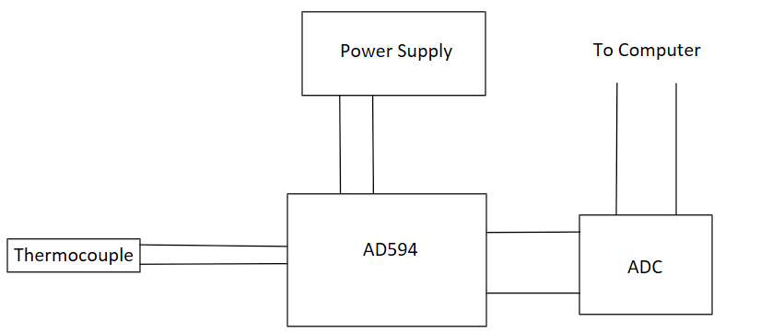

**Measuring Thermistor Output**

We used a thermistor to calibrate the output of the thermocouple. The accuracy of the thermistor’s measurements are within ±0.2 ℃. We calibrated the thermistor by immersing it in two baths of known temperatures – an ice bath, assumed to be 0 ℃, and boiling water, assumed to be 100 ℃. The thermistor constants are: Ro: 9647.88 Ω and β: 3617.58 K, calculated using the thermistor equation shown below, where To is 298.15 K.

$R=R_{o}e^{\left[β\left(\frac{1}{T}-\frac{1}{T_{o}}\right)\right]}$ (3)

**Hot and Cold Water Baths**

We used an Oster deep fryer to heat 1.5 L of water to a boil, liquid water was replaced periodically to keep the volume relatively constant. The cold water bath consisted of a bowl of ice filled with water. When sensors were immersed in the hot water bath, they were placed in such a way that they would not touch the bottom or sides of the container. When placed in the cold water bath, the sensors came into direct contact with ice. The assumption that the ice water bath is 0 ℃ can be maintained to the confidence of ±0.1 ℃ based on the purity of city water in the town of Durham NH, where we conducted this experiment. The local air pressure can affect the boiling point of water. The National Oceanic and Atmospheric Administration operates a weather station near the location of this experiment (Station IOSN3). The barometric pressure at sea level at the exact time of the experiment was 1009.5 mBar. The sea level pressure in the seacoast region of New Hampshire historically varies between 1005 mBar and 1025 mBar during the month of February [1]. The calculated boiling point range is therefore between 99.77 ℃ and 100.32 ℃, leaving an uncertainty of ±0.27 ℃ [2]. The expected boiling point of water at the time of the experiment is 99.90 ℃.

**Methods of Data Analysis**

We determined static sensitivity by immersing both the bare wire thermocouple, and the thermistor in water baths of known temperatures. We then plotted their temperature data together such that a perfect response from each sensor would yield a line with a slope of 1. The plot describing this can be found in the appendix, on page 21, (top figure). We determined the confidence intervals at 95% confidence using ten data points.

**Determination of Time Constants**

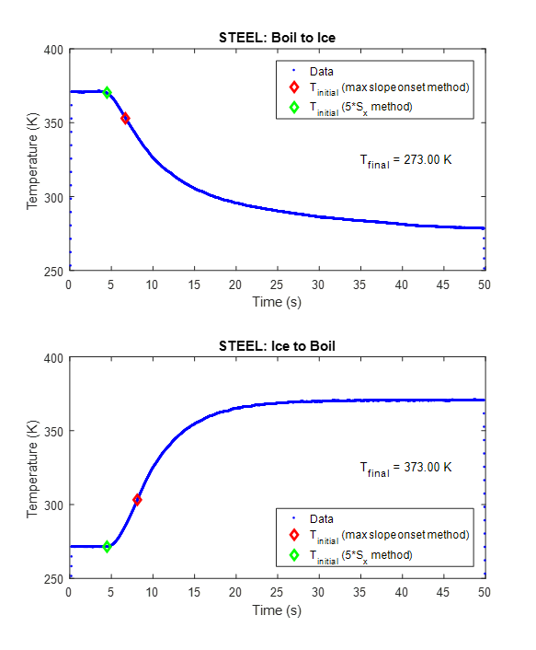

Figure 3 – A Temperature vs. Time curve of the stainless steel embedded thermocouple transitioning from the ice water bath to the boiling water bath.

The error fraction ln(Γ) used to obtain the time constant τ is found by taking the natural log of Γ, shown below (equation 2)

$Γ=\frac{T_{final}-T(t)}{T_{final}-T_{initial}}=e^{-\frac{t}{τ}}$ (2)

We plotted time vs. ln(Γ), then found the best fit line using the method of linear regression. The slope of this best fit line is equal to the negative inverse of the time constant, ao. We then manipulated ao to solve for the time constant, τ (equation 1).

$τ=-\frac{1}{a_{o}}$ (1)

The data inputted to the best fit line function in MATLAB were truncated to prevent imaginary numbers in the predicated value of ln(Γ) which would be caused by taking the natural log of a negative number. The y-intercept of our time value was forced to zero because the MATLAB function we used required this assumption to work properly (i.e. the beginning of the temperature change event occurred at time t=0, and any time leading up to this event is negative).

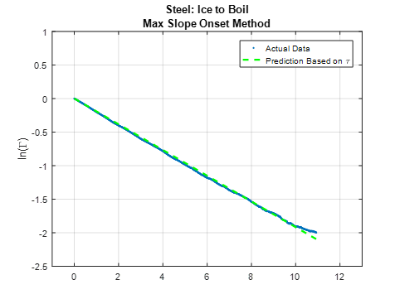

Figure 4 – A typical plot of ln(Γ) vs. time. The slope of the green dashed line is used to directly calculate the time constant, τ

A second method used the assumption that the time constant is the time at the index of the time/temperature array, where the following condition is true (equation 4)

$T@\left(t=τ\right)=T_{initial}+.632(T_{final}-T_{initial})$ (4)

In MATLAB, the temperature at the point where time is equal to one time constant can be solved for by equation 4, the time constant value is located at the same index in the time array that this temperature is in the temperature array. See figure 1 in the introduction.

EXPERIMENTAL RESULTS AND DISCUSSION

**Initial Time Determination**For every thermocouple and transition type tested, we found that the maximum-slope onset method consistently gave us a greater time value than values provided by the five sigma onset method (figures 5, 6, 7). This is explained through human influence, and by air having a lower heat transfer coefficient than water. When the thermocouple is taken out of one bath, the 1st order response starts immediately when it contacts the air, before any human can transfer it to another bath. We are only interested in the thermocouple response corresponding to the thermocouple being placed in a new bath. The five sigma method triggers as soon as the temperature exceeds a deviation of five standard deviations from the baseline temperature mean, which occurs as soon as the thermocouple makes contact with the air and before it makes contact with the water bath. The maximum slope of the temperature vs. time data will occur when the thermocouple enters the water bath in question, due to water’s greater heat transfer coefficient than that of air. This is especially visible in the bare wire thermocouple (Figure 6**)** due to its additionally quick response.



Figure 5 - Aluminum Embedded Thermocouple. Transition from Boil to Ice. This is a plot of temperature output from the thermocouple vs. time, and compares the two initial onset times determined by the two different methods.



Figure 6 - Stainless Steel Thermocouple. Transition from Boil to Ice. This is a plot of temperature output from the thermocouple vs. time, and compares the two initial onset times determined by the two different methods.



Figure 7 - Bare Wire Thermocouple. Transition from Boil to Ice. This is a plot of temperature output from the thermocouple vs. time, and compares the two initial onset times determined by the two different methods.

Thermocouple in air

The rapid response to a change in temperature from the bare wire thermocouple is explained by its low thermal mass (ρ*Cv). The quick response is represented in our analysis with small time constant values of less than 0.45 for every test involving the bare wire thermocouple. Alternitively, the embedded thermocouples have a larger thermal mass, and larger time constant values, all greater than 3.7. (See Table 1 for a list of Syx and time constant values for every test set up.) This means that the material the thermocouple is embedded into will absorb and store heat energy before the thermocouple registers a change in environmental temperature. Therefore, the embedded thermocouples will have a slower initial response to a change in environmental temperature. This slow response will cause the data from the thermocouple in air and the data from the thermocouple emersed in the new water bath to be almost indestiguishable using either onset method. The maximum slope method will still be more accurate than the five sigma method in this case, however, neither onset method will yield a result as accurate as the results obtained with the bare wire thermocouple tests for the time durations considered.

**Time Constant Determination – Bare Wire Thermocouple**

For the bare wire thermocouple transitioning from boiling to ice water and analyzed using the maximum slope onset method, the ln(Γ) vs. time fit for determining the time constant worked well. Specifically, the standard error of the fit (Syx) was 0.43. This was our lowest, and hence most accurate prediction of the time constant. Similarly, Syx was 0.47 for the bare wire transition from ice to boiling water, predicted using the ln(Γ) vs. t method. For both water bath transitions, the 63.2% estimation method was not substaintially inferior to the ln(Γ) vs. time method, and resulted in 0.46 Syx for boiling water to ice water and 0.54 Syx for ice water to boiling water.



Figure 8 - Bare Wire Thermocouple: Transition from ice to boiling water.

Both time constant estimation methods proved to be inaccurate when using the five sigma onset method, (disregarding transition type) generating Syx values between 7.24 and 10.26. This becomes clear when looking at Figure 8 and noticing that the predictions of the responses do not match the actual data very well for the five sigma onset method, disregarding which time constant estimation method was used. These trends are also visible in Figure 9, which shows a plot of the residuals vs. time for each combined method to determine the time constant.

Overall, for the bare wire thermocouple, the maximum slope onset method was the most accurate method for determining the initial time of the thermocouple entering the water bath. The ln(Γ) vs. t method was slightly more accurate than the 63.2% of final temperature in predicting the time constant, however, both of these methods were acceptable.

**Embedded Thermocouples**



Figure 9 - Bare Wire Thermocouple: Transition from boiling water to ice water. Comparing residuals between predicted data based on estimated τ values and actual data for all four prediction methods.

Apart for one exception (Stainless Steel embedded thermocouple transitioning from boiling water to ice), all embedded thermocouple transitions (boil to ice and ice to boil), analyzed using time shifted data from the maximum-slope onset method and either time constant estimation method, provided reasonable Syx values ranging from 0.74 to 2.96.

The responses analyzed using the five sigma onset method were not as accurate, and generated Syx values between 2.54 and 5. The precision between residual curves and Syx values shows that there is minimal variation between different time constant estimation methods. For example, in Figure 10, it is clear that although the predictions vary greatly between different onset methods, the Syx and residual curves do not vary significantly between different time constant estimation methods.



Figure 10 - Aluminum Embedded Thermocouple: Transition from boiling to ice water. This figure shows the residuals of the actual vs. predicted data plotted vs. time. The Standard Error of the Fit (Syx) is listed on the figure for each of the four methods.

Reasoned from their larger time constant values (seen in Table 1), the embedded thermocouples take longer to react to their environment, inducing slight inaccuracies in both onset methods. Looking at the predictions vs. the actual data in Figure 11 , along with the shown Syx values provides good visual evidence of this.

In summary, we concluded similar results regarding estimation methods for both bare wire and embedded thermocouples. In all cases, the five sigma onset method provided a more accurate estimation of the time constant value. Generally speaking, the ln(Γ) vs. time method was more accurate than the 63.2% method, however, there was not a significant trend in either method resulting in a higher accuracy consistently.



Figure 11 - Aluminum Embedded Thermocouple: Transition from ice to boiling water.

**Time Constant Trends**

|  |  |  |  |  |  |
| --- | --- | --- | --- | --- | --- |
| **Method** | | | | **τ(s)** | **Sxy(°C)** |
| **ALUMINUM EMBEDDED THERMOCOUPLE** | **Boil → Ice** | five sigma | ln(Γ) Fit | 6.139 | 2.56 |
| 0.632 τ | 6.369 | 2.43 |
| Max Slope | ln(Γ) Fit | 5.534 | 0.77 |
| 0.632 τ | 5.57 | 0.74 |
| **Ice → Boil** | five sigma | ln(Γ) Fit | 4.64 | 4.18 |
| 0.632 τ | 4.96 | 3.92 |
| Max Slope | ln(Γ) Fit | 3.79 | 2.93 |
| 0.632 τ | 3.75 | 2.96 |
| **STEEL EMBEDDED THERMOCOUPLE** | **Boil → Ice** | five sigma | ln(Γ) Fit | 11.5 | 3.92 |
| 0.632 τ | 9.51 | 4.99 |
| Max Slope | ln(Γ) Fit | 12.23 | 4.4 |
| 0.632 τ | 9.63 | 4.75 |
| **Ice → Boil** | five sigma | ln(Γ) Fit | 6.48 | 4.16 |
| 0.632 τ | 6.76 | 3.94 |
| Max Slope | ln(Γ) Fit | 5.22 | 1.7 |
| 0.632 τ | 5.08 | 1.76 |
| **BARE WIRE THERMOCOUPLE** | **Boil → Ice** | five sigma | ln(Γ) Fit | 0.29 | 8.55 |
| 0.632 τ | 0.23 | 7.24 |
| Max Slope | ln(Γ) Fit | 0.033 | 0.43 |
| 0.632 τ | 0.031 | 0.46 |
| **Ice → Boil** | five sigma | ln(Γ) Fit | 0.33 | 10.26 |
| 0.632 τ | 0.256 | 9.71 |
| Max Slope | ln(Γ) Fit | 0.05 | 0.47 |
| 0.632 τ | 0.045 | 0.54 |

Table 1 Syx and Time Constant values for all test set ups.

Pictured to the right is a table listing our resulting time constants and Syx values from all of the completed tests. The first predominant trend is highlighted using a blue-orange color gradient, and compares the time constant values for different transition types. In general, transitions from ice water to boiling water resulted in a smaller time constant values, and therefore a faster response to temperature change. Table 1. This is explained through the effect of bath-fluid velocity. In the boiling water bath, fluid is moving at a much faster rate, increasing the rate of heat transfer (proven through laws of convection). Therefore, when a thermocouple is transferred from an ice water bath to a boiling water bath with a high heat transfer rate, the response will be much faster than when the thermocouple is transferred to an ice bath with slower moving particles and slower a heat transfer rate. This trend is less visible in the bare wire thermocouple because it already responded very quickly, and therefore we cannot see this trend as accurately.

As described in a previous section, response rate, and therefore the time constant, is dependent upon the thermal mass of the material of the embedded thermocouple, volume, area, and heat transfer coefficient. This relationship is derived from Equation 5, and is represented in Equation 6.

$q= ρVc_{v}\frac{dT}{dt}= -hA_{s}(T\left(t\right)-T_{∞})$ (5)

$τ= \frac{ρVc_{v}}{hA_{s}}$ (6)

Because the volumes and areas are the same for both embedded thermocouples, you can create a ratio, or lumped capacitance model comparing the time constants for Aluminum and Stainless Steel, assuming both are placed in the same environment with identical heat transfer coefficients. This relationship is represented in Equation 7.

$\frac{τ_{Al}}{τ_{SS}}= \frac{ρ_{Al}c_{vAl}}{ρ_{SS}c_{vSS}}= \frac{2.7(0.9)}{8.03(0.5)} ≈0.6$ (7)

From equation 7, it can be deduced that $τ_{Al }< τ_{SS }$. This would imply that the Aluminum embedded thermocouple would have a smaller time constant than the Stainless Steel embedded thermocouple. As seen in the Table 1 the Aluminum embedded thermocouples do have smaller time constants than their Stainless steel counterparts for the respective transition types. Therefore, our observations agree with our predicted trends for embedded thermocouple time constants.

SUMMARY AND CONCLUSIONS

From our initial calibration, we determined the confidence intervals of the fit and measurement for the thermocouple temperature measurements. At the end of our range, around 0oC and 100oC, we found the confidence limit to be 2.42 x 10-5 ± 1.67 oC. At the middle of our temperature range, around 50oC, the confidence limit is 49.4 ± 1.48 oC. These limits describe the accuracy of the sensors used in reviewing and analyzing different methods for determining the thermal time constant of the sensors when placed in water baths.

The most accurate method to determine the thermal time constant involves using the time corresponding to the maximum absolute slope of the temperature vs. time data as the initial time, and by using the slope of the best fit line for ln(Γ) vs. time to determine the time constant. However, after an appropriate initial time is found, determining the time constant as the time it takes to reach 63.2% of the final temperature difference between water baths will also provide a similarly accurate result.

Finally, once time constant values were determined, we found that the lumped capacitance model did in fact describe the trends in the time constants correctly. As predicted, the time constants for Aluminum were smaller than those of Stainless Steel.

APPENDIX

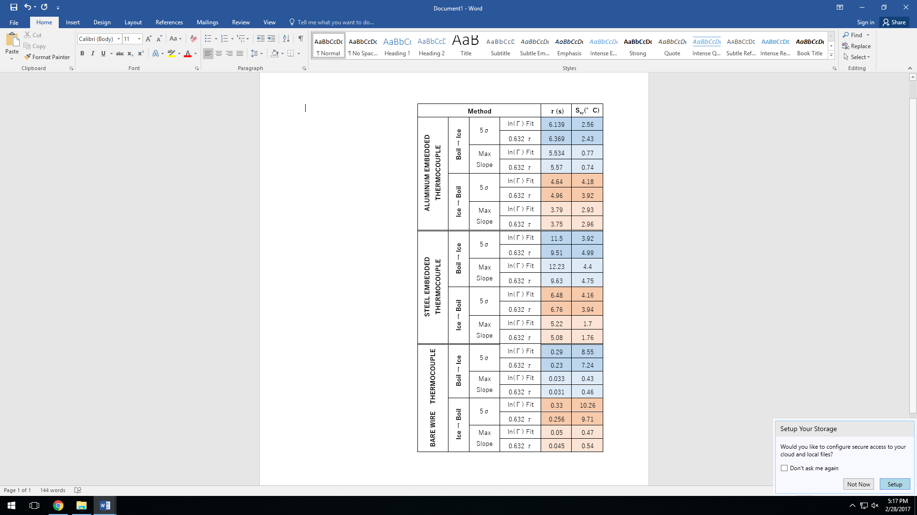



The data from the thermocouple are well within the confidence interval of both the fit and measurement, more points are expected to land in the same area within the confidence interval of the measurement. The confidence interval of the fit represents how certain we are about the location of the best fit line (95% confidence). The confidence interval of the measurement represents how certain we are that the next measurement will land within the upper and lower bounds (which represent 95% certainty).



We transferred the bare wire thermocouple to room temperature air from water, however the temperature did not reach room temperature in the two minutes we recorded data for. This is most likely due to the fact that the water on the thermocouple is keeping it cool. The specific heat of water is approximately 8 times that of steel, and requires a considerable amount of energy to heat (4.186 kJ/(kg*K)). In addition to its high thermal mass, the water evaporates, which cools the thermocouple.

REFERENCES

|  |  |
| --- | --- |
| [1] | National Oceanic and Atmospheric Administration, "National Data Buoy Center," 26 February 2017. [Online]. Available: www.ndbc.noaa.gov/view_climplot.php?station=iosn3&meas=sl. [Accessed 26 February 2017]. |
| [2] | A. Shipway and S. Shipway, "Boiling Points," 2008. [Online]. Available: www.calctool.org/CALC/chem/substance/boiling. [Accessed 26 February 2017]. |